1. **INTRODUCTION**

A CubeSat is a nanosatellite with dimensions of 10×10×10 cm and a mass of 1.33 kg. Like other satellites, the main source of energy for a CubeSat is solar energy [1]. The Electrical Power System (EPS) of a CubeSat collects solar energy, converts it to electrical energy, stores it, and distributes it to the satellite's other subsystems. The EPS is vital to the satellite and must be built to ensure maximum efficiency and robust performance.

**2. Defining Power Requirements**

**a) Power Budget**

The power budget is determined by the amount of power needed by each subsystem, the amount of power produced by solar cells, and the amount of power stored in batteries. The power budget will be positive if the power generated during one orbit is greater than or equal to the power used during the orbit. In contrast, it will be negative if the power generated during one orbit is less than the power spent during this orbit; in this scenario, the battery will steadily drain until it is empty.

* A power budget helps calculate how much energy your CubeSat needs.
* You list all major subsystems (OBC, communication, payload, etc.) and estimate their power consumption in watts.
* Peak power (~6–10W) is the maximum draw during active periods.
* Average power (~4–5W) is what the CubeSat uses typically per orbit.

**b) Mission Profile**

* Defines how long your CubeSat will be in the sun vs. shadow (important for battery sizing).
* In LEO, each 90-minute orbit has about 55 minutes sunlight and 35 minutes eclipse.
* During eclipse, the system relies entirely on batteries.
* Different operational modes (nominal, science, safe) vary in power consumption.

**c) Mission Duration**

* Long missions require battery degradation planning.
* For 6–12-month missions, select batteries with good cycle life and reliability.

**3. EPS Core Components**

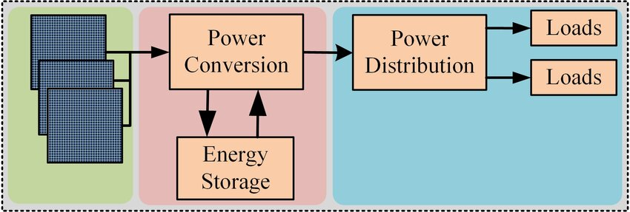

**a) Power Generation – Solar Panels**

* Solar panels are the CubeSat’s primary energy source.
* Triple-junction GaAs cells are best for space (up to 30% efficiency), but more expensive.
* Body-mounted panels are simpler but generate less power; deployable add more area (and power) but increase risk.
* Important specs: Voltage (per panel), current output, and tolerance to space temperatures.

Calculating the power generation as follow:

Power (W) = Solar Irradiance (W/m²) x Solar Panel Area (m²) x Solar Panel Efficiency x Cosine Loss Factor

This is the average power generation when the CubeSat is in sunlight.Assuming the CubeSat spends certain percentage of its orbit in sunlight, the average power generation over the entire orbit can be calculated as the following:

Average Power (W) = Total Power (W) x Sunlight Percentage

**(i)Energy Used**

The energy used during the eclipse time by using the following equation:

*Ee=Pnd×Te*

where Pnd represents the power available to the subsystem including loss, and Te is the Eclipse Time.

The required minimum capacity of the battery for the nanosatellite is another crucial value to be aware of.The batteries' stringent minimum capacity is:

$$C=\frac{Ee}{v}$$

The capacity of Li-ion batteries slightly decreases at each charge and discharge cycle. A depth of discharge (DoD) of 30% or less is recommended. The ideal capacity for our battery is

$$Ci=\frac{C}{DoD}$$

**b) Power Storage – Batteries**

The battery stores excess solar energy from the solar cells and supplies energy to the satellite when the solar arrays are shaded. The main criteria when selecting the battery is the battery capacity and the physical dimensions of the cell. Battery performance is a critical aspect of this work. Therefore, the focus has been placed on maintaining and ensuring the efficiency and life of the batteries for the entire

mission duration. As the battery charges and discharges, it will display a sinusoidal graph. However, the most important aspect is to ensure that the battery has a positive linear relationship between the charging percentage and time. The battery should continue charging and increasing the percentage of charge over time. The most commonly used type of lithium-ion cells for CubeSats is the cylindrical 18650 COTS cells.

* Li-ion or Li-Po batteries offer high energy density and are space-compatible.
* 2S1P means 2 cells in series, 1 in parallel = 7.4V nominal voltage.
* To size your battery:
  + Calculate energy needs during eclipse .
  + Add safety margin (~30%) for inefficiencies and aging, 3Wh minimum.
  + Actual batteries used are often 20–50Wh to allow full operation and autonomy.
* **Battery Protection**

The Lithium polymer battery is very volatile when the cell is overcharged or over discharged. A dedicated battery protection circuit is needed for each cell to make sure the batteries remain within the bounds of normal operation. Therefore, the battery protection circuit must disable the battery when overcharged, disable the battery when over discharged, and only monitor one cell per circuit. The single cell per circuit criteria is driven by the scalability of the distributed 36 EPS; if more voltage is needed on the unregulated bus, then battery modules need to be easily added in series with each other without modification to the circuit. The battery protection circuit needs to provide telemetry for data such as the battery voltage and battery current.

* Batteries need **BMS (Battery Management System)** to protect against:
  + Overvoltage, undervoltage
  + Short circuits
  + Imbalance between cells

**c) Power Regulation – PMAD System**

* PMAD (Power Management and Distribution) The **PMAD** system is responsible for taking power from the solar panels and batteries and distributing it safely and efficiently to all CubeSat subsystems (like the OBC, communications, payload, etc.) at the correct voltages and currents.
* Uses DC-DC converters:
  + Buck: Lowers voltage.
  + Boost: Increases voltage.
  + Buck-boost/SEPIC: Handles fluctuating input voltages.
* MPPT (Maximum Power Point Tracking) ensures solar panels operate at their most efficient point. MPPT chips automatically adjust the load to extract maximum power.
* LDOs (Low Dropout Regulators) are linear regulators used for noise-sensitive systems like analog sensors.

**d) Power Distribution**

After voltage regulation, the Power Distribution system ensures that power is delivered reliably and safely to all CubeSat subsystems. This is handled by the central PMAD (Power Management and Distribution) board, which routes power to various modules such as:

* OBC (On-Board Computer)
* Payloads
* Communication systems
* ADCS (Attitude Determination and Control System)
* Sensors, etc.

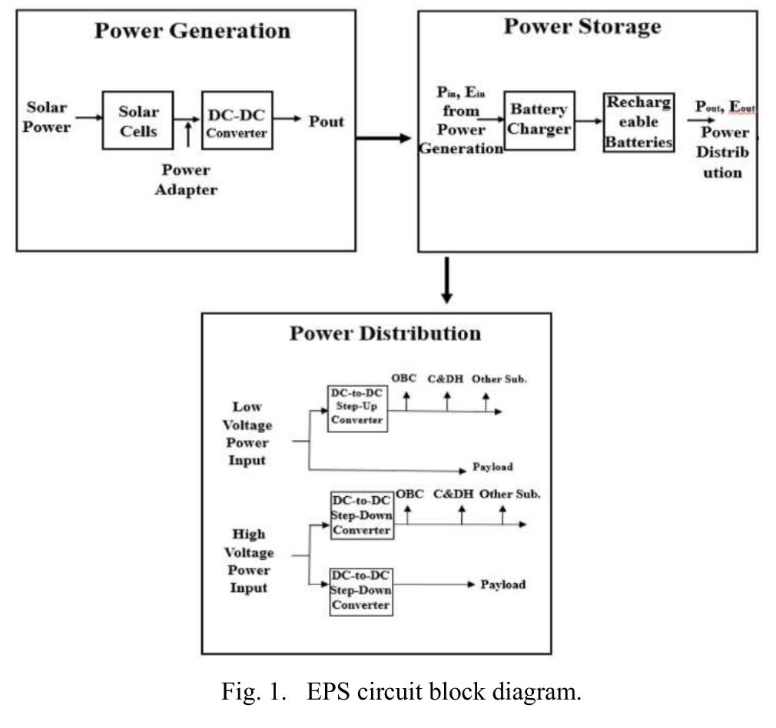

**Switching Subsystems On/Off**

To conserve energy and ensure safety, each subsystem can be turned on or off independently using:

**1. MOSFETs (Metal-Oxide Semiconductor Field-Effect Transistors)**

* MOSFETs act as electronic switches controlled by a microcontroller or logic circuit. They offer fast switching, low resistance, and minimal power loss. Configured as high-side (between power and load) or low-side (between load and ground), they efficiently control power flow to subsystems.

**2. SSRs (Solid-State Relays)**

* Solid-State Relays (SSRs) are electronic relays without moving parts, making them reliable and silent. They are useful for isolating high-voltage paths or protecting sensitive loads. However, due to their larger size and weight, they are more common in bigger satellites, while CubeSats typically prefer compact and efficient MOSFETs.